**Self-made Soldering station**

|  |  |
| --- | --- |
| Author | Lucas Cosemans |

Content

1 Introduction 1

2 Material and methods 2

3 Results 2

3.1 Subtitle 1 2

3.1.1 Subtitle 2

3.1.2 Subtitle 2

3.2 Subtitle 2 2

3.2.1 Subtitle 2

3.2.2 Subtitle 2

4 Discussion 2

5 Reference list 2

# Introduction

The school subject named ‘Project-Ontwerpen’ is learning the students how to have and make a project from start to finish. This projects contains learning on how to make a Programmable Circuit Board (PCB) with ‘Altium Designer’. Drawing and printing in 3D using ‘Fusion 360’ and a 3D printer is also learned along the way. The software licenses that are needed are bought by school so that this is free of charge for the students. After the designing part of the project is done the electronic components will be soldered on the custom-made PCB. In an elketor magazine is an article that describes this project. In this application note the self-made soldering station project will be described with great detail.

# Material and methods

[Give an overview of the materials and the methods you used:

Materials: the components for the device

* Which materials (i.e. hardware and software) did you use and did you compare?
* Which materials were not useful and why not? Use proper, objective evaluation criteria.
* Add the Bill of Materials including an indication of the price, supplier name and delivery date (table in English!)

Methods: specific tools and procedures you use to collect and analyze data (for example, experiments, datasheets…)

* Include a schematic representation (i.e. flowdiagram) and explain this representation by providing a step by step overview of the design process, production process and testing process (including a description of the mechanical design).

**+/- 500 words**]

**Methods:**

Every electronic engineering project starts with an idea. The idea to build a soldering station came from an Elektror magazine. This magazine is a time magazine that writes about the newest electronic components and projects from other people. Every two months they publish a new edition (Digital and printed). The Idea for the article about the soldering station came from Luc Lemmens and Mathias Claussen (Both working for Elektor). The article contains all the schematics and components that were used for this project.

The class organized a group-buy to order most of the electronic components. This is useful to prevent ordering wrong components. The rest of the components are then ordered by Gotron (local electronics store).

**Electronic components:**

|  |  |  |  |
| --- | --- | --- | --- |
| Resistors | Order URL | Type | # |
| 18 Kohm | <https://www.lcsc.com/product-detail/Chip-Resistor-Surface-Mount_VO-SCR0805J18K_C3017916.html> | 805 | 3 |
| 1 Mohm | <https://www.lcsc.com/product-detail/Chip-Resistor-Surface-Mount_FOJAN-FRC0805J105-TS_C2907302.html> | 805 | 1 |
| 68 Kohm | SCR0805J68K | 805 | 1 |
| 5,6 Kohm | SCR0805J5K6 | 805 | 4 |
| 10 Kohm | <https://www.lcsc.com/product-detail/Chip-Resistor-Surface-Mount_UNI-ROYAL-Uniroyal-Elec-0805W8F1002T5E_C17414.html> | 805 | 6 |
| 100 ohm | <https://www.lcsc.com/product-detail/Chip-Resistor-Surface-Mount_UNI-ROYAL-Uniroyal-Elec-0805W8F1000T5E_C17408.html> | 805 | 3 |
| 10 Mohm | <https://www.lcsc.com/product-detail/Chip-Resistor-Surface-Mount_FOJAN-FRC0805J106TS_C2930232.html> | 805 | 1 |
| 4,7 Kohm | <https://www.lcsc.com/product-detail/Chip-Resistor-Surface-Mount_FOJAN-FRC0805J472-TS_C2907326.html> | 805 | 6 |
| Inductor |  |  |  |
| L1 | <https://www.lcsc.com/product-detail/Power-Inductors_KOHERelec-PMI201214S-100M_C2922559.html> | 805 | 1 |
| L2 | [**https://www.mouser.be/ProductDetail/875-CM**](https://www.mouser.be/ProductDetail/875-CM2545X171R-10) | 2545 | 1 |
| Capacitor |  |  |  |
| 4700 uF | <https://www.lcsc.com/product-detail/Aluminum-Electrolytic-Capacitors-Leaded_CX-Dongguan-Chengxing-Elec-GR478M050O25RR0VZ2FPD_C45663.html> | D25xL25mm plugin | 1 |
| 10 uF | <https://www.lcsc.com/product-detail/Aluminum-Electrolytic-Capacitors-SMD_ST-Semtech-CS1E100M-CRC54_C98750.html> | D4XL5,4 | 3 |
| 100 nF |  | 805 | 6 |
| 100 uF | <https://www.lcsc.com/product-detail/Aluminum-Electrolytic-Capacitors-SMD_Nichicon-UWT1H101MNL1GS_C445063.html> | SMD,D8xL10mm | 2 |
| 10 nF | <https://www.lcsc.com/product-detail/Multilayer-Ceramic-Capacitors-MLCC-SMD-SMT_CCTC-TCC0805X7R103M500DT_C376921.html> | 805 | 7 |
| Semiconductors |  |  |  |
| 1n4007 | A7 | SOD-123Fl | 1 |
| Zener | <https://www.lcsc.com/product-detail/Zener-Diodes_Shandong-Jingdao-Microelectronics-BZT52C5V1_C353516.html> | SOD-123Fl | 1 |
| 1n14148 | <https://www.lcsc.com/product-detail/Switching-Diode_Shandong-Jingdao-Microelectronics-1N4148W_C115103.html> | SOD-123Fl | 1 |
| Brug | <https://www.lcsc.com/product-detail/Bridge-Rectifiers_MDD-Microdiode-Electronics-TTR8MF_C712546.html> | TTF | 2 |
| BC847C | <https://www.lcsc.com/product-detail/Bipolar-Transistors-BJT_SALLTECH-BC847C_C3027113.html> | SOT-23 | 3 |
| MOSFET-P | <https://www.lcsc.com/product-detail/MOSFETs_UTC-Unisonic-Tech-UTT18P10L-TN3-R_C84900.html> | TO-252-2(DPAK) | 1 |
| BC857C | <https://www.lcsc.com/product-detail/Bipolar-Transistors-BJT_Jiangsu-Changjing-Electronics-Technology-Co-Ltd-BC857_C2139.html> | SOT-23 | 1 |
| DC/DC | <https://www.mouser.be/ProductDetail/580-OKI78SR5-1.5W36C> | ? | 1 |
| MCP6002-E/MS | <https://www.mouser.be/ProductDetail/Microchip-Technology-Atmel/MCP6002-E-MS?qs=huzeVNXgovXv0kPjGdVLUA%3D%3D> | MSOP-8 | 1 |
| Mircocontroler | <https://www.mouser.be/ProductDetail/556-ATMEGA4809-AU> | TQFP-48 | 1 |
| relay | <https://www.mouser.be/ProductDetail/TE-Connectivity-PB/RT424005F?qs=8wHch9UpSvaH%252B%252BmsSCbj0Q%3D%3D> | ? | 1 |
| IC2 7seg | <https://www.lcsc.com/product-detail/LED-Display-Drivers_TM-Shenzhen-Titan-Micro-Elec-TM1637-TA2007_C5337160.html> | SOP-20 | 1 |
| encoder | <https://www.lcsc.com/product-detail/Rotary-Encoders_BOURNS-PEC11R-4220F-S0012_C143817.html> | ? | 1 |

(The schematics from the Elektor magazine and the ‘PWM’ schematic in Altium Designer)

**Using Altium Designer:**

In order to make a PCB there need to be two libraries made. One schematic.lib (for the schematic drawing of the used components) and one PCB.lib (for the footprints on the PCB of every used component). In total there are five (‘Voeding’, ‘CPU’, ‘thermokoppel’, ‘Display’ and ‘PWM’) schematics made by taking the drawing from the schematic.lib file. Once all the schematics are drawn the footprints are validated for every component. At the end the PCB is made by loading the drawn schematics into the PCB file and then replace everything to a more logical place. The made PCB is made to saw into two pieces, one driving PCB and one PCB for the display. At this point it is known what the PCB will look like and a case can be made to protect it and make it appeal better.

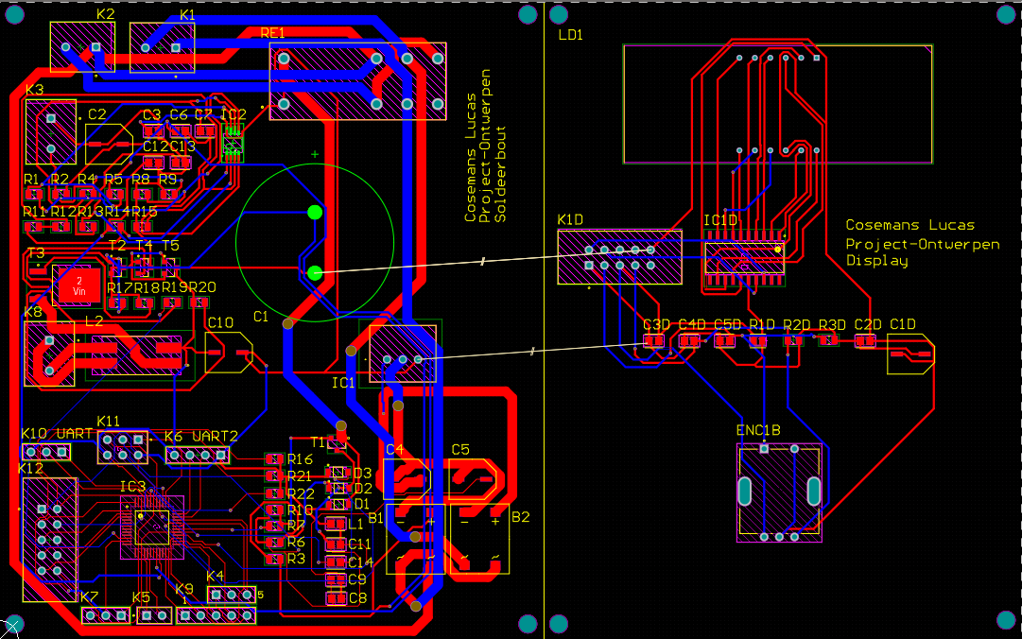(routed PCB – in Altium Designer)

**Making the case:**

The case is made from a material called PLA. This material is commonly used for 3D printing. A 3D printer needs a .gcode file in order to print. This .gcode file is made with a slicer that like the name already says slices the 3D model in to layers. The 3D printer now knows how to move the ‘nozzle’ (place where melted PLA comes from). To slice a 3D model a 3D drawing/model is needed, to draw this model ‘Fusion 360’ is used. As same as ‘Altium Designer’ this software cad be used with a school licence.

Fusion 360 is 3D oriented drawing space. First a 2D drawing (same as on a paper) needs to be drawn using lines and pre-made figures (rectangles, circles, etc.) to make it easier. When the 2D drawing is made this can be extruded. What it actually does is place the 2D drawing x amount of times behind or in front of the previous drawing.

**Finishing:**

Once PCB design is done, the (virtual) PCB is send to a company that makes PCB’s. If the custom PCB arrives and the electronic components have been collected. The components can be soldered in the right place on the PCB. When the PCB is finished it can be programmed with a programme given by the teacher. At the end the self-build soldering station is tested and assembled together with the 3D printed case. The project is now finished.

# Results

[Describe the end result you accomplished.

* Describe every aspect of your device. How does it function?
* Add an image of the electrical schematic, PCB design, finalized mechanical design, and finalized product

Write a well-structured text using subtitles and paragraphs.

**+/-500**]

When everything is soldered onto the PCB, the case is 3D printed and the errors are taken care of the self-made soldering station in finished.

## Soldering station

### Why is it not finished:

The microcontroller (=electronic component that manages and drives everything) used for the project is a ATMEGA4809-AU. This electronic device is very small, therefore it can be easily damaged. When the microcontroller is damaged it cannot be programmed to drive the soldering station. To make things worse the microcontroller is capable of connecting/bridging components that may not be connected in any way. The whole soldering station will not be working because of this small most important components.   
The microcontroller could not be replaced in time because in the ‘group-buy’ there were no extra microcontrollers bought and the lector also did not have a spare one.

### Not working result:

The result of a not working ‘self-made soldering station’ is a well-designed PCB with every component soldered onto it except for the ATMEGA4809 microcontroller. The PCB is sawn into two separate pieces that will later be connected with a flat-cable. The PCB is now more flexible and therefore it is easier to fit in the case designed for it.

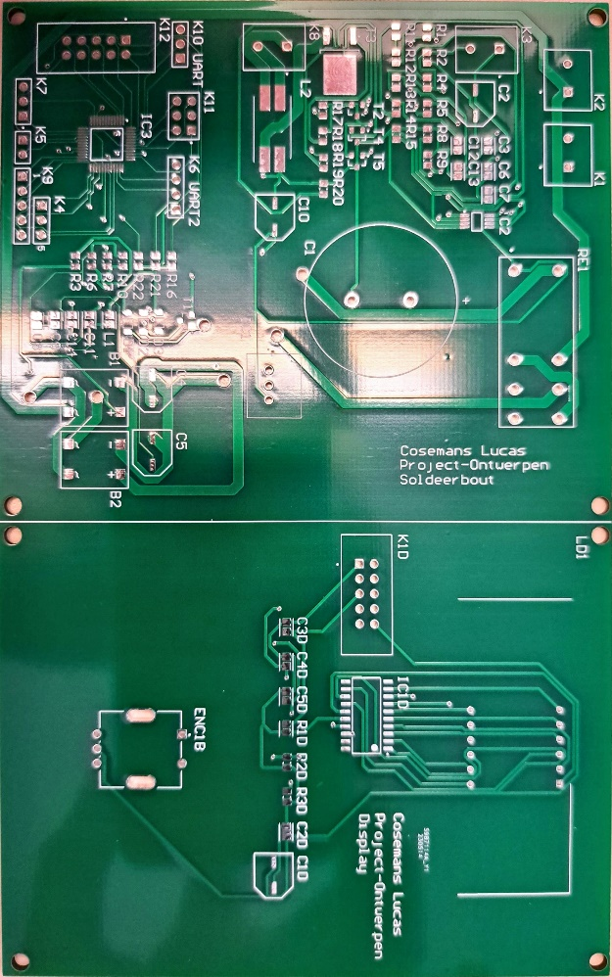

## The Case

### Subtitle

### Subtitle

# Discussion

[Reflect on and discuss your project.

* Which difficulties did you encounter during the design process and why? How did you solve these issues?
* Reflect on the process: did things go as expected? Would you choose the same approach if you had to do the project all over again? Are there issues that still need to be fixed? How come?

**+/-300 words**]

The project was introduced very early in the 2th semester. This meant that there was a lot of time to work on the project at the beginning. Every week there was less time to work on the project end near the end of the 2th semester there is hardly any time left at all. Therefore ‘Time-Management’ is worthy of mentioning here as a thing to keep in mind whilst working on a project. Besides time-management is being patient also a good point to mention here. Sometimes things go slower than expected, at that point it’s all about being patient and not breaking anything because of a rushing work-style. Of course there are some things that can not be solved. In this case the microcontroller is damaged. This could only be solved by removing the damaged microcontroller and replacing it, but if there are no spare microcontrollers that’s not an option. For future projects it’s good to keep in mind that sometimes electronic components break and therefore spare parts must be bought.

# Reference list

[Insert your reference list here.]